Student’s name | …………………………………………………….…… | Grade | 1
Subject | Computer | Week No. | 13
Lesson Title | Introduction to Digital Art | Unit
Worksheet No. ( 13 ) (Answer)

Question A: write the correct name of each part

Search | Brushes | Tools | Color 1
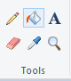
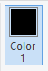
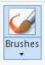

Brushes
Color 1
Tools
Search
Good Luck

